**RandomPageRedirect User Manual**

This feature will allow a user to be redirected to a random page, any of which is listed in the index page of the wiki.

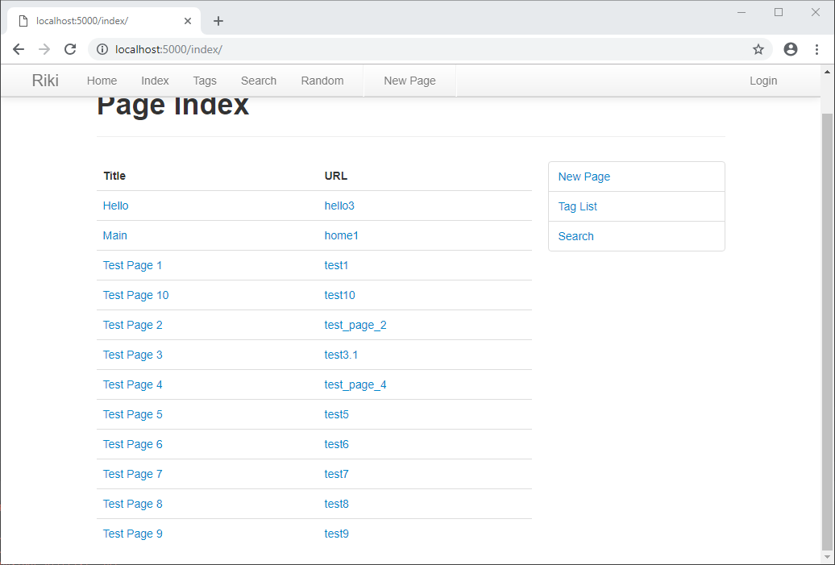

You will be redirected to any url within your wiki index page

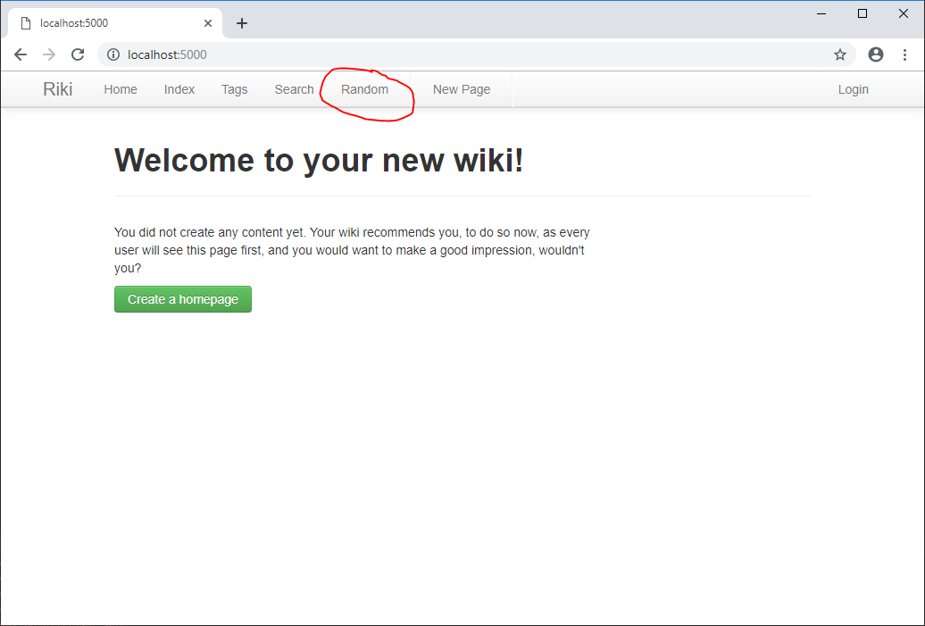

* Start on any wiki page. You will see the Random option in the navbar at the top of every page. You can click on this to be redirected to a page or do the following.
* You can also append /random to your current url to be redirected to a random page

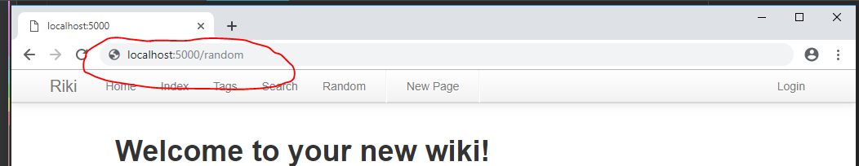

1. You will be redirected to any page within your index tab

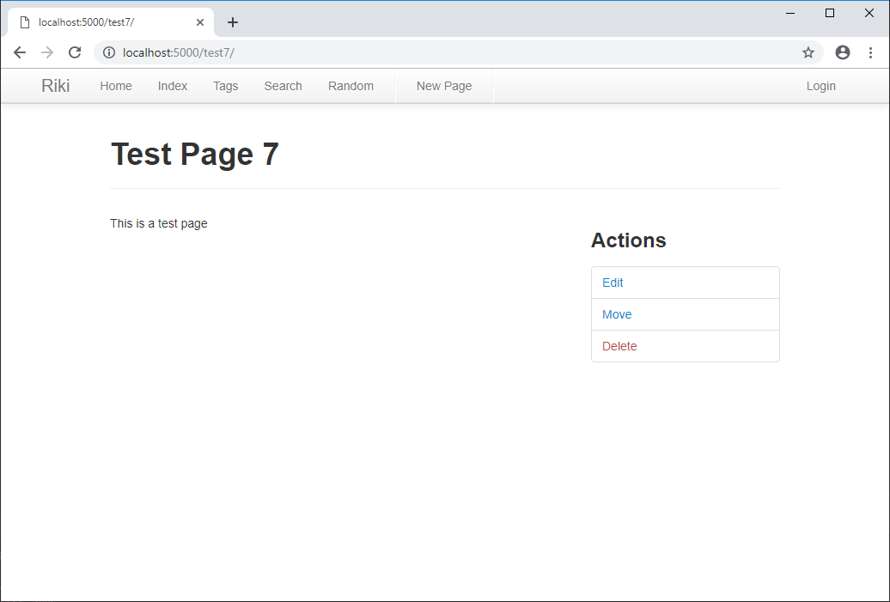

Random Page Accessed